**DIAGNOSIS OF PNEUMOTHORAX USING**

**DEEP LEARNING**

**A PROJECT REPORT**

***Submitted by***

**ALEX MOSES INBARAJ.A 211418107004**

**DINESH.R 211418107026**

**GNANA SAI.A.R 211418107029**

***in partial fulfillment for the award of the degree of***

**BACHELOR OF ENGINEERING**

***in***

**ELECTRONICS AND INSTRUMENTATION ENGINEERING**



**PANIMALAR ENGINEERING COLLEGE**

**(An Autonomous Institution, Affiliated to Anna University, Chennai)**

**MAY 2022**

**PANIMALAR ENGINEERING COLLEGE**

**(An Autonmous Institution, Affiliated to Anna University, Chennai)**

**BONAFIDE CERTIFICATE**

Certified that this project report **“DIAGNOSIS OF PNEUMOTHORAX USING DEEP LEARNING”** is the bonafide work of **“ALEX MOSES INBARAJ.A (211418107004),DINESH.R(211418107026),GNANA SAI.A.R(211418107029)”** who carried out the project work under my supervision**.**

|  |  |
| --- | --- |
| **SIGNATURE** | **SIGNATURE** |
|  |  |
| **Dr. C. ESAKKIAPPAN, M.E., Ph.D.,**  **Head of the Department**,  Professor,  Department of Electronics and Instrumentation Engineering,  Panimalar Engineering College, Chennai – 123 | **Dr. R. MANIKANDAN, M.E., Ph.D., SUPERVISOR**,  Professor,  Department of Electronics and Instrumentation Engineering,  Panimalar Engineering College, Chennai - 123 |

Certified that the above mentioned students were examined in Anna University project viva-voice held on _________________________.

**INTERNAL EXAMINER EXTERNAL EXAMINER**

**ACKNOWLEDGEMENT**

We would like to express our deep gratitude to our beloved **Secretary and Correspondent Dr.P.CHINNADURAI, M.A., Ph.D.,** for his kind words and enthusiastic motivation which inspired tableus a lot in completing this project and we express our sincere thanks to our **Directors Mrs.C.VIJAYA RAJESWARI and Dr.C.SAKTHI KUMAR M.E.Ph.D,** for providing us with necessary facilities for completion of this project.

We also express gratitude to our Principal **Dr.K.MANI,M.E., Ph.D.,** who has been source of constant encouragement and support.

We would also like to express our gratitude to **Dr.C.ESAKKIAPPAN,M.E., Ph.D.,** Head of the Department, Electronics and Instrumentation Engineering, for his valuable guidance, ideas and encouragement for successful completion of this project.

We would like to thank our internal guide **Dr.R.MANIKANDAN,M.E,Ph.D.,** Professor of the Department, Electronics and Instrumentation Engineering.

We take this opportunity to thank our beloved parents, friends and teachers for their constant support and encouragement.

**ABSTRACT**

A pneumothorax (noo-moe-THOR-aks) is a collapsed lung. A pneumothorax occurs when air leaks into the space between your lung and chest wall. This air pushes on the outside of your lung and makes it collapse. A pneumothorax can be a complete lung collapse or a collapse of only a portion of the lung. A collapsed lung occurs when air enters the pleural space, the area between the chest wall and the lung. Air in the pleural space can build up and press against the lung, causing it to collapse partially or fully. Also called a deflated lung or pneumothorax, a collapsed lung needs immediate medical care.

The proposed system is based on CNN using images to classifying, pneumothorax or Normal in this system using CNN model. It is predicted that the success of the obtained results will increase if the CNN method is supported by adding extra feature extraction methods and successfully identified pneumothorax.

We have demonstrated the efficacy and potential of using deep CNN to images.

**Keywords:** Pneumothorax, deep learning, TensorFlow, Keras, CNN.

|  |  |  |  |  |  |  |
| --- | --- | --- | --- | --- | --- | --- |
| **CHAPTER NO.** | **TITLE** | | | | **PAGE NO.** | |
|  | **ABSTRACT** | | | | iv | |
|  | **LIST OF TABLES** | | | | vii | |
|  | **LIST OF FIGURES** | | | | viii | |
|  | **LIST OF ABBREVIATIONS** | | | | ix | |
| 1 | **INTRODUCTION** | | | | 01 | |
|  | 1.1 | Types of Pneumothorax | | |  | |
|  |  | 1.1.1 | | Primary Pneumothorax | 02 | |
|  |  | 1.1.2 | | Secondary Pneumothorax | 02 | |
|  |  | 1.1.3 | | Tension or Non-Tension Pneumothorax | 03 | |
|  |  | 1.1.4 | | Traumatic Pneumothorax | 03 | |
|  | 1.2 | Symptoms &Risk | | | 04 | |
| 2 | **LITERATURE SURVEY** | | | | 06 | |
| 3 | **EXISTING SYSTEM** | | | | 11 | |
|  | 3.1 | Limitations of Existing system | | | 14 | |
| 4 | **PROPOSED SYSTEM** | | | | 15 | |
|  | 4.1 | Usecase Diagram | | | 16 | |
|  | 4.2 | Convolutional Neural Network | | | 16 | |
|  |  | 4.2.1 | Architecture Of CNN | | 17 | |
|  | 4.3 | ALEXNET | | | 21 | |
|  |  | 4.3.1 | Architecture of ALEXNET | | 21 |
|  | 4.4 | LENET | | | 22 |
|  |  | 4.4.1 | Architecture of LeNet-5 | | 22 | |
|  | 4.5 | Preparing The Dataset | | | 23 | |
|  | 4.6 | Import The Given Image from Dataset | | | 23 | |
|  | 4.7 | To Train the Module by Given Image Dataset | | | 24 | |
|  | 4.8 | Working Process of Layers In CNN | | | 24 | |
|  | 4.9 | Work Flow Diagram | | | 26 | |
|  | 4.10 | Advantages | | | 26 | |
| 5 | **SOFTWARE IMPLEMENTATION** | | | | 27 | |
|  | 5.1 | Working Process | | | 27 | |
|  | 5.2 | Splitting the Dataset | | | 28 | |
|  | 5.3 | Construction of Detecting Model | | | 28 | |
|  | 5.4 | PyCharm | | | 28 | |
|  | 5.5 | List of Modules | | | 29 | |
| 6 | **RESULTS AND DISCUSSION** | | | | 30 | |
|  | 6.1 | Results for Pneumothorax | | | 30 | |
|  | 6.2 | Analysis Based on Loss Scores | | | 30 | |
|  | 6.3 | Evaluation metrics | | | 31 | |
|  | 6.4 | Output of Proposed System | | | 33 | |

|  |  |  |
| --- | --- | --- |
| 7 | **CONCLUSION & FUTURE SCOPE** | 35 |
|  | **APPENDICES** | 36 |
|  | **REFERENCES** | 47 |

**LIST OF TABLES**

|  |  |  |
| --- | --- | --- |
| **TABLE NO.** | **TITLE** | **PAGE NO.** |
| **I** | Classification Performance Using Image Search as A Classifier on Dataset | 12 |
| **II** | Formula Used for various Architecture | 13 |
| **III** | The Pneumothorax Performance of The Presented Deep Learning | 13 |
| **IV** | AUC Interpretation & Guidelines | 33 |
|  |  |  |
|  |  |  |
|  |  |  |

**LIST OF FIGURES**

|  |  |  |
| --- | --- | --- |
| **FIGURE NO.** | **TITLE** | **PAGE NO.** |
| 1.1 | A Graphical illustration of pneumothorax | 1 |
| 1.2 | Tension Pneumothorax | 3 |
| 1.3 | Types of Pneumothorax | 4 |
| 3.1 | Analysis for Dataset | 12 |
| 4.1 | Usercase Diagram | 16 |
| 4.2 | The Architecture of CNN | 17 |
| 4.3 | Architecture of AlexNet | 21 |
| 4.4 | Architecture of LeNet | 23 |
| 4.5 | CNN model Summary | 24 |
| 4.6 | Work Flow Diagram | 26 |
| 5.1   |  | | --- | | 6.1 | | 6.2 | | Source code Implementation in Pycharm   |  | | --- | | CNN model trained dataset accuracy | | CNN model trained dataset loss values | | 28  30  31 |
| 6.3 | Pneumothorax Identified Using CNN | 33 |
| 6.4 | Input Image data sample | 34 |
| 6.5 | Final output of proposed system | 34 |

**LIST OF ABBREVIATIONS**

CNN - Convolutional Neural Network

FC - Fully Connected Layer

PTX - Pneumothorax

CT - Computer Tomography Scan

AI - Artificial Intelligence

CXR - Chest X-ray

AUC - Area under the ROC Curve

**CHAPTER 1**

**INTRODUCTION**

A **pneumothorax** is an abnormal collection of air in the [pleural space](https://en.wikipedia.org/wiki/Pleural_space) between the [lung](https://en.wikipedia.org/wiki/Lung) and the [chest wall](https://en.wikipedia.org/wiki/Chest_wall). Symptoms typically include sudden onset of sharp, one-sided [chest pain](https://en.wikipedia.org/wiki/Chest_pain) and [shortness of breath](https://en.wikipedia.org/wiki/Dyspnea). In a minority of cases, a one-way valve is formed by an area of damaged [tissue](https://en.wikipedia.org/wiki/Tissue_(biology)), and the amount of air in the space between chest wall and lungs increases; this is called a tension pneumothorax. This can cause a steadily worsening [oxygen shortage](https://en.wikipedia.org/wiki/Hypoxia_(medical)) and [low blood pressure](https://en.wikipedia.org/wiki/Hypotension). This leads to a type of shock called [obstructive shock](https://en.wikipedia.org/wiki/Obstructive_shock), which can be fatal unless reversed. Very rarely, both lungs may be affected by a pneumothorax. It is often called a "collapsed lung", although that term may also refer to [atelectasis](https://en.wikipedia.org/wiki/Atelectasis).

**Pneumothorax**



**Fig 1.1:** A Graphical illustration of Pneumothorax

A primary spontaneous pneumothorax is one that occurs without an apparent cause and in the absence of significant [lung disease](https://en.wikipedia.org/wiki/Lung_disease). A secondary spontaneous pneumothorax occurs in the presence of existing lung disease. Smoking increases the risk of primary spontaneous pneumothorax, while the main underlying causes for secondary pneumothorax are [COPD](https://en.wikipedia.org/wiki/COPD), [asthma](https://en.wikipedia.org/wiki/Asthma), and [tuberculosis](https://en.wikipedia.org/wiki/Tuberculosis). A traumatic pneumothorax can develop from [physical trauma](https://en.wikipedia.org/wiki/Physical_trauma) to the [chest](https://en.wikipedia.org/wiki/Chest) (including a [blast injury](https://en.wikipedia.org/wiki/Blast_injury)) or from a [complication of a healthcare intervention](https://en.wikipedia.org/wiki/Iatrogenesis).

Diagnosis of a pneumothorax by [physical examination](https://en.wikipedia.org/wiki/Physical_examination) alone can be difficult (particularly in smaller pneumothoraces). A [chest X-ray](https://en.wikipedia.org/wiki/Chest_radiograph), [computed tomography](https://en.wikipedia.org/wiki/X-ray_computed_tomography) (CT) scan, or [ultrasound](https://en.wikipedia.org/wiki/Ultrasound) is usually used to confirm its presence. Other conditions that can result in similar symptoms include a [hemothorax](https://en.wikipedia.org/wiki/Hemothorax) (buildup of [blood](https://en.wikipedia.org/wiki/Blood) in the pleural space), [pulmonary embolism](https://en.wikipedia.org/wiki/Pulmonary_embolism), and [heart attack](https://en.wikipedia.org/wiki/Myocardial_infarction). A large [bulla](https://en.wikipedia.org/wiki/Chronic_obstructive_pulmonary_disease#Pathophysiology) may look similar on a chest X-ray.

A small spontaneous pneumothorax will typically resolve without treatment and requires only monitoring. This approach may be most appropriate in people who have no underlying lung disease. In a larger pneumothorax, or if there is shortness of breath, the air may be removed with a [syringe](https://en.wikipedia.org/wiki/Syringe) or a [chest tube](https://en.wikipedia.org/wiki/Chest_tube) connected to a one-way valve system. Occasionally, [surgery](https://en.wikipedia.org/wiki/Surgery) may be required if tube drainage is unsuccessful, or as a preventive measure, if there have been repeated episodes. The surgical treatments usually involve [pleurodesis](https://en.wikipedia.org/wiki/Pleurodesis) (in which the layers of [pleura](https://en.wikipedia.org/wiki/Pleura) are induced to stick together) or [pleurectomy](https://en.wikipedia.org/wiki/Pleurectomy) (the surgical removal of pleural membranes). About 17–23 cases of pneumothorax occur per 100,000 people per year. They are more common in men than women.

**1.1 Types of Pneumothorax**

Various causes of pneumothoraces exist and each pneumothorax is classified according to its cause.

**1.1.1Primary Pneumothorax**

Also referred to as a spontaneous pneumothorax or primary spontaneous pneumothorax. It is characterized by having no clear cause or no known underlying lung pathology.

There may be contributing factors, such as cigarette smoke, family history, the rupture of the bulla (small air-filled sacs in the lung tissue) but these will not cause pneumothorax itself.

**1.1.2 Secondary Pneumothorax**

Also referred to as a non-spontaneous or complicated pneumothorax. It occurs as a result of an underlying lung pathology such as [COPD](https://www.physio-pedia.com/COPD_(Chronic_Obstructive_Pulmonary_Disease)), [Asthma](https://www.physio-pedia.com/Asthma), [Tuberculosis](https://www.physio-pedia.com/Tuberculosis), [Cystic Fibrosis](https://www.physio-pedia.com/Cystic_Fibrosis) or Whooping Cough.

**1.1.3 Tension or Non-Tension Pneumothorax**

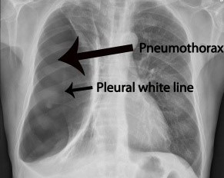

**Fig:1.2** Tension Pneumothorax

A pneumothorax can further be classified as tension or non-tension pneumothorax. A tension pneumothorax is caused by excessive pressure build up around the lung due to a breach in the lung surface which will admit air into the pleural cavity during inspiration but will not allow any air to escape during expiration. The breach acts as a one-way valve. This leads to lung collapse.The removal of the air is through the surgical incision by inserting an underwater drain in the pleural cavity. This excessive pressure can also prevent the heart from pumping effectively which may lead to shock. A non-tension pneumothorax is not considered as severe as there is no ongoing accumulation of air and therefore there is no increased pressure on the organs and the chest.

**1.1.4 Traumatic Pneumothorax**

Other causes of a pneumothorax can be trauma or incorrect medical care.A traumatic pneumothorax is caused by trauma to the lungs. Some of the causes are the following: Stab wound, gunshot, or injury from a motor vehicle accident or any other trauma to the lungs. A pneumothorax which develops as a result of a medical procedure or incorrect medical care i.e. accidental puncture to the lung during surgery is termed as an iatrogenic pneumothorax.

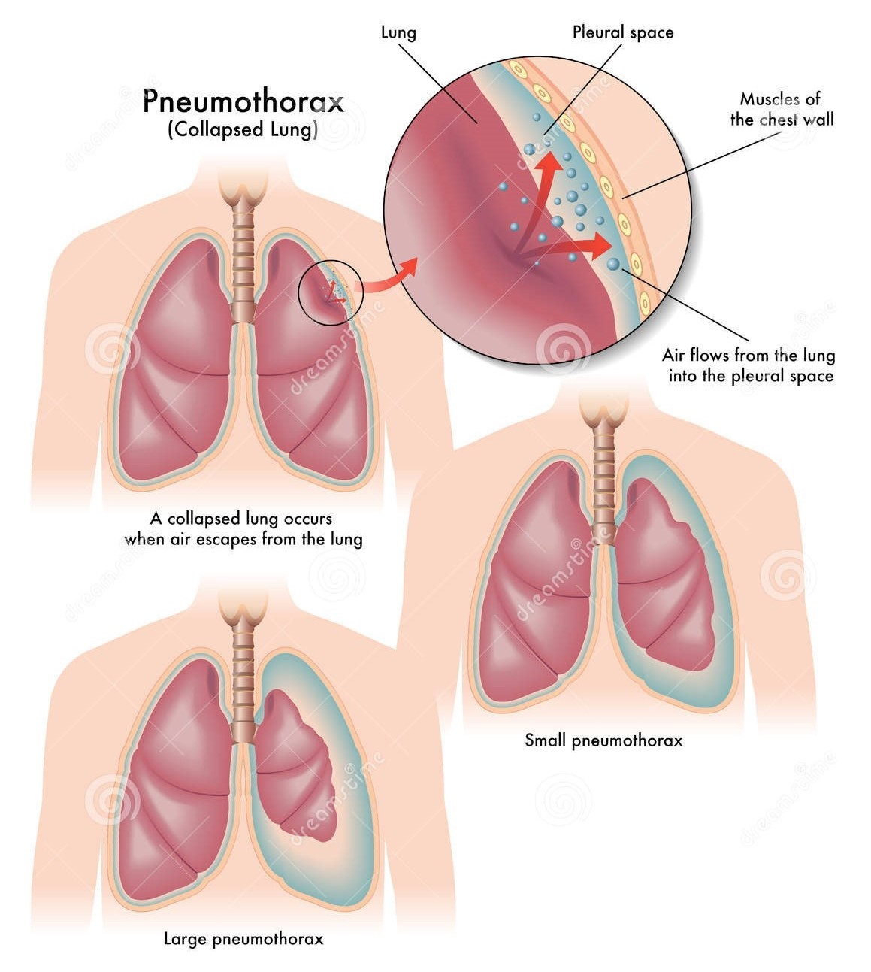

**Fig1.3:** Types of Pneumothorax

**1.2 Symptoms and Risk**

**Symptoms:**

* sudden, sharp stabbing pain on one side of the chest that gets worse when you breathe in feeling breathless.
* You’ll usually be diagnosed by a chest X-ray. Sometimes you’ll also have a CT scan of your chest.

**Who is at risk of a pneumothorax?**

It’s more likely for men to have a pneumothorax than women. A primary spontaneous pneumothorax is more likely to happen in tall, thin people.

You’re more likely to have a pneumothorax if:

* you have an existing lung condition
* you smoke
* you have had a pneumothorax in the past

**How is a pneumothorax treated?**

The treatment of a pneumothorax depends on its size, and whether it’s expanding, as well as what has caused it. The aim is to relieve the pressure on your lung to allow it to re-expand.

If the pneumothorax is small, and the tear in your lung is small, the leak usually heals itself in a few days and the trapped air is gradually absorbed by your body. You can use over-the-counter painkillers if the pain is bad. You may have an X-ray after a week or so to check the pneumothorax has gone.If a pneumothorax is causing breathlessness, you may be given oxygen.

**The excess air may be removed by:**

* Inserting a needle into the air-filled space and sucking the air out through a very thin tube using a syringe.
* This is called aspiration using a chest drain. This is a flexible plastic tube that’s inserted through the chest wall, after the area is numbed.
* The drain allows air out but not back in, so your lung can re-inflate.
* The tube is secured and stays in place until the air leak has resolved and the lung re-inflated.
* You will have to stay in hospital until it has resolved. On average, this is around 2 – 5 days, but it can be longer.
* If a pneumothorax occurs more than once on the same side or an air leak persists despite aspiration or a chest drain, you might need to have a small operation.
* This will seal the weak areas on the edge of the lung where the air leaks are happening.
* This surgery may also involve a form of [pleurodesis](https://www.blf.org.uk/support-for-you/mesothelioma/treatment/treating-pleural-effusion), where the lung is stuck to the inside of the chest wall, to make sure the lung can’t collapse again.

**CHAPTER 2**

**LITERATURE SURVEY**

**a)Title**: Automatic Diagnosis of Pneumothorax from Chest Radiographs:A Systematic Literature Review

**Author**: Tahira Iqbal , Arslan Shaukat , Usman Akram

**Year**: 2015

Among various medical imaging tools, chest radiographs are the most important and widely used diagnostic tool for detection of thoracic pathologies. Researches are being carried out in order to propose robust automatic diagnostic tool for detection of pathologies from chest radiographs. Artificial Intelligence techniques especially deep learning methodologies have been found to be giving promising results in automating the field of medicine. Lot of research has been done for automatic and fast detection of pneumothorax from chest radiographs while proposing several frameworks based on artificial intelligence and machine learning techniques. This study summarizes the existing literature for the automatic detection of pneumothorax from chest x-rays along with describing the available chest radiographs datasets. The comparative analysis of the literature is also provided in terms of goodness and limitations of the existing literature along with highlighting the research gaps which need to be further explored. The paper provides a brief overview of the present work for pneumothorax detection for helping the researchers in selection of optimal approach for future research.

**b)Title**: Effective Pneumothorax Detection for Chest X-Ray Images Using Local Binary Pattern and Support Vector Machine

**Author**: [Yuan-Hao Chan](https://pubmed.ncbi.nlm.nih.gov/?term=Chan+YH&cauthor_id=29849996), [Yong-Zhi Zeng](https://pubmed.ncbi.nlm.nih.gov/?term=Zeng+YZ&cauthor_id=29849996), [Hsien-Chu Wu](https://pubmed.ncbi.nlm.nih.gov/?term=Wu+HC&cauthor_id=29849996), [Ming-Chi Wu](https://pubmed.ncbi.nlm.nih.gov/?term=Wu+MC&cauthor_id=29849996), [Hung-Min Sun](https://pubmed.ncbi.nlm.nih.gov/?term=Sun+HM&cauthor_id=29849996)

**Year**: 2018

Automatic image segmentation and feature analysis can assist doctors in the treatment and diagnosis of diseases more accurately. Automatic medical image segmentation is difficult due to the varying image quality among equipment. In this paper, the automatic method employed image multiscale intensity texture analysis and segmentation to solve this problem. In this paper, firstly, SVM is applied to identify common pneumothorax. Features are extracted from lung images with the LBP (local binary pattern). Then, classification of pneumothorax is determined by SVM. Secondly, the proposed automatic pneumothorax detection method is based on multiscale intensity texture segmentation by removing the background and noises in chest images for segmenting abnormal lung regions. The segmentation of abnormal regions is used for texture transformed from computing multiple overlapping blocks. The rib boundaries are identified with Sobel edge detection. Finally, in obtaining a complete disease region, the rib boundary is filled up and located between the abnormal regions.

**c)Title**: Deep Learning for Pneumothorax Detection and Localization in Chest Radiographs

**Author**: [André Gooßen](https://arxiv.org/search/eess?searchtype=author&query=Goo%C3%9Fen%2C+A), [Hrishikesh Deshpande](https://arxiv.org/search/eess?searchtype=author&query=Deshpande%2C+H), [Tim Harder](https://arxiv.org/search/eess?searchtype=author&query=Harder%2C+T), [Evan Schwab](https://arxiv.org/search/eess?searchtype=author&query=Schwab%2C+E), [Ivo Baltruschat](https://arxiv.org/search/eess?searchtype=author&query=Baltruschat%2C+I), [Thusitha Mabotuwana](https://arxiv.org/search/eess?searchtype=author&query=Mabotuwana%2C+T), [Nathan Cross](https://arxiv.org/search/eess?searchtype=author&query=Cross%2C+N), [Axel Saalbach](https://arxiv.org/search/eess?searchtype=author&query=Saalbach%2C+A)

**Year**: 2019

Pneumothorax is a critical condition that requires timely communication and immediate action. In order to prevent significant morbidity or patient death, early detection is crucial. For the task of pneumothorax detection, we study the characteristics of three different deep learning techniques: (i) convolutional neural networks, (ii) multiple-instance learning, and (iii) fully convolutional networks. We perform a five-fold cross-validation on a dataset consisting of 1003 chest X-ray images. ROC analysis yields AUCs of 0.96, 0.93, and 0.92 for the three methods, respectively. We review the classification and localization performance of these approaches as well as an ensemble of the three aforementioned techniques.

**d)Title**: Deep learning for chest X-ray analysis: A survey

**Author**: [ErdiÇall](https://www.sciencedirect.com/science/article/pii/S1361841521001717" \l "!) , [EcemSogancioglu,](https://www.sciencedirect.com/science/article/pii/S1361841521001717#!)  [Bramvan Ginneken](https://www.sciencedirect.com/science/article/pii/S1361841521001717#!),[Kicky G.van Leeuwen](https://www.sciencedirect.com/science/article/pii/S1361841521001717#!), [KeelinMurphy](https://www.sciencedirect.com/science/article/pii/S1361841521001717#!)

**Year**: 2021

Recent advances in deep learning have led to a promising performance in many [medical image analysis](https://www.sciencedirect.com/topics/medicine-and-dentistry/image-analysis-medical-imaging) tasks. As the most commonly performed radiological exam, chest radiographs are a particularly important modality for which a variety of applications have been researched. The release of multiple, large, publicly available chest X-ray datasets in recent years has encouraged research interest and boosted the number of publications. In this paper, we review all studies using deep learning on chest radiographs published before March 2021, categorizing works by task: image-level prediction (classification and regression), segmentation, localization, image generation and domain adaptation. Detailed descriptions of all publicly available datasets are included and commercial systems in the field are described. A comprehensive discussion of the current state of the art is provided, including caveats on the use of public datasets, the requirements of clinically useful systems and gaps in the current literature.

**e)Title:** Deep Learning-Based Computer-Aided Pneumothorax Detection Using Chest X-ray Images

**Author:** Priyanka Malhotra , Sheifali Gupta , Deepika Koundal , Atef Zaguia , Manjit Kaur and Heung-No Lee.

**Year:** 2022

Pneumothorax is a thoracic disease leading to failure of the respiratory system, cardiac arrest, or in extreme cases, death. Chest X-ray (CXR) imaging is the primary diagnostic imaging techniquefor the diagnosis of pneumothorax. A computerized diagnosis system can detect pneumothoraxin chest radiographic images, which provide substantial benefits in disease diagnosis. In the presentwork, a deep learning neural network model is proposed to detect the regions of pneumothoraces in the chest X-ray images. The model incorporates a Mask Regional Convolutional Neural Network(Mask RCNN) framework and transfer learning with ResNet101 as a backbone feature pyramid network (FPN). The proposed model was trained on a pneumothorax dataset prepared by the Society for Imaging Informatics in Medicine in association with American college of Radiology (SIIM-ACR).The present work compares the operation of the proposed MRCNN model based on ResNet101 as an FPN with the conventional model based on ResNet50 as an FPN. The proposed model had lower class loss, bounding box loss, and mask loss as compared to the conventional model based on ResNet50 as an FPN. Both models were simulated with a learning rate of 0.0004 and 0.0006 with 10 and 12 epochs, respectively.

**CHAPTER 3**

**EXISTING SYSTEM**

The chest Xray is the diagnostic modality of choice when pneumothorax is suspected. The computer-aided diagnosis of pneumothorax has received a dramatic boost in the last few years due to deep learning advances and the first public pneumothorax diagnosis competition with 15257 chest X-rays manually annotated by a team of 19 radiologists. This paper describes one of the top frameworks that participated in the competition. The framework investigates the benefits of combining the Unet convolutional neural network with various backbones, namely ResNet34, SE-ResNext50, SEResNext101, and DenseNet121. The paper presents a step-by-step instruction for the framework application, including data augmentation, and different pre- and post-processing steps. The performance of the framework was of 0.8574 measured in terms of the Dice coefficient

Learning Framework In Comparison To The Performance Of Three Experienced Radiologists.

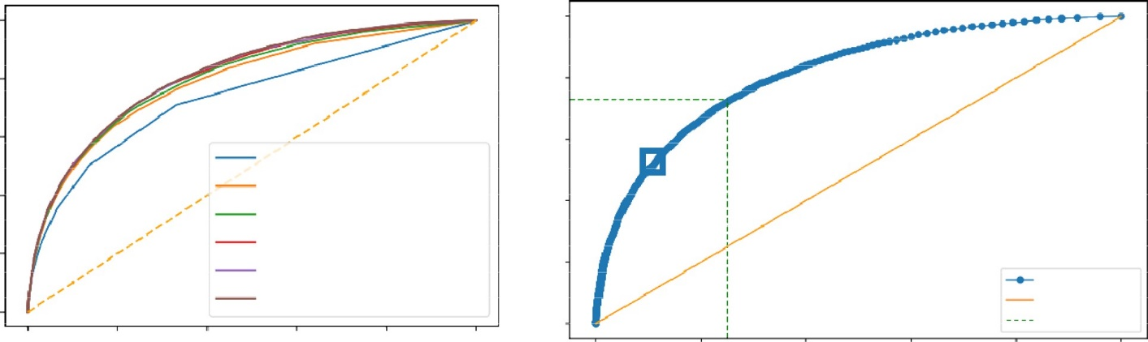

1.0

0.01 0.01 0.01 0.0

0.0

0.0

0.03

0.02 0.02

0.03

0.8

0.04

0.04

0.05

0.06

0.6

k = 11, AUC=0.736 k = 51, AUC=0.791 k = 101, AUC=0.803 k = 251, AUC=0.810 k = 501, AUC=0.813

k = 1001, AUC=0.815

0.07

0.08

0.09

0.1

12

0.4

0.2

0.15

0.17

0.2

0.23

0.26

0.31

0.36

0.41

0.47

0.6

0.0

ROC Curve

Diagonal Optimal Point

0.0

0.2

0.4

0.6

0.8

1.0

0.0

0.2

0.4

0.6

0.8

1.0

**Fig 3.1.** Analysis for Dataset. Left: Sample ROC curves for the proposed *AutoThorax*-Net for different *k* values in one fold and their area under the curve (AUC), Right: corresponding ROC thresholds for *k* = 1001 to select the sensitivity–specificity trade-off using Youden’s index.

The mean X-ray 𝑰̅ and standard deviation 𝝈 over all pixels in all the X-rays were computed and then used to normalize all X-rays to the same intensity frame: 𝑰𝑘←𝑰𝒌−𝑰̅𝝈.The result evaluation was performed using the mean Dice coefficient for all the images: **𝐷𝑖𝑐𝑒=2|𝑆𝑟𝑒𝑓∩𝑆𝑎𝑢𝑡𝑜||𝑆𝑟𝑒𝑓|∪|𝑆𝑎𝑢𝑡𝑜|**

**TABLE I**

**Classification Performance Using Image Search as a Classifier On Dataset**

|  |  |  |  |
| --- | --- | --- | --- |
| **Method** | **Sensitivity** | **Specificity** | **AUC** |
| CheXNet classifier | 72 | 67 | 77 |
| Search via *AutoThorax*- net features (*k* = 1001) | 73 | 75 | 82 |
| Search via *AutoThorax*- net features (*k* = 501) | 73 | 75 | 82 |
| Search via *AutoThorax*- net features (*k* = 251) | 72 | 75 | 82 |
| Search via *AutoThorax*- net features (*k* = 101) | 69 | 78 | 81 |
| Search via *AutoThorax*- net features (*k* = 51) | 70 | 75 | 80 |
| Search via *AutoThorax*- net features (*k* = 11) | 72 | 67 | 74 |
| Search via configuration 3 (3072 features, *k* = 1001) | 72 | 63 | 75 |
| Search via configuration 3 (3072 features, *k* = 501) | 70 | 67 | 76 |
| Search via configuration 3 (3072 features, *k* = 251) | 71 | 67 | 76 |
| Search via configuration 3 (3072 features, *k* = 101) | 74 | 65 | 77 |

A summary of classification performance using image search as a classifier on Dataset . The numbers (in percentage) are the result of averaging 10 folds with very low standard deviation (< 1%).

**TABLE II**

**FORMULA USED FOR VARIOUS ARCHITECTURES**

|  |  |  |  |
| --- | --- | --- | --- |
| **Algorithm** | CheXNet,AutoThorax-Net | UNet, Res-Net | Lenet,Alex-Net |
| **Result Evaluation** | 𝑰𝑘←𝑰𝒌−𝑰̅𝝈. | 𝑝-value < 1𝑒−10 | 𝑝-value < 1𝑒−10 |
| **Training Data** | Wcj = | 𝐷𝑖𝑐𝑒=2|𝑆𝑟𝑒𝑓∩𝑆𝑎𝑢𝑡𝑜||𝑆𝑟𝑒𝑓|∪|𝑆𝑎𝑢𝑡𝑜| | Wcj = |

**TABLE III**

**The Pneumothorax Performance of The Presented Deep Learning**

|  |  |  |  |  |  |  |  |
| --- | --- | --- | --- | --- | --- | --- | --- |
| Framework results | | | | Dice coefficient | | | |
| Framework | | Radiologist #1 | | Radiologist #2 | | Radiologist #3 | |
| Correctly labeled pneumothorax X-ray | 0.9277 | | 0.8509 | | 0.8216 | | 0.8746 |
| Mis-labeled pneumothorax X-ray | 0 | | 0.0251 | | 0.1501 | | 0.1290 |
| Mis-labeled non-pneumothorax X-ray | 0 | | 0.7500 | | 0.5833 | | 0.4167 |
| Correctly labeled non-pneumothorax X-ray | 1 | | 0.9778 | | 0.9333 | | 1 |
| All X-rays | 0.5520 | | 0.632 | | 0.629 | | 0.637 |

**3.1 Limitations of Existing system**

* Medical department wants to automate the detecting of pneumothorax disease from eligibility process (real time).
* To optimize the work to implement in Artificial Intelligence environment.

**CHAPTER 4**

**PROPOSED SYSTEM:**

We are proposing recognition framework based on the structured two dimensional Convolutional Neural Networks (CNNs) type of AlexNet to identify the Pneumothorax and improve the accuracy of workflow.

* The proposed method for this project is to train a Deep Learning algorithm capable of identifying pneumothorax images and data preprocessing and visualizing the image then feature extracting to build AlexNet CNN using Pneumothorax image dataset.we identfy it such as Pneumothorax or Normal using CNN model.
* It is predicted that the success of the obtained results will increase if the CNN method is supported by adding extra feature extraction methods and classify successfully Pneumothorax. We have demonstrated the efficacy and potential of using deep CNN to images.The objective of using this method is to get some features which are specifically responsible for the Pneumothorax disease prediction.

**4.1 USECASE DIAGRAM**



People

People

**Fig:4.1** Usecase Diagram

**4.2 CONVULUTIONAL NEURAL NETWORK**

A Convolutional neural network (CNN) is one type of Artificial Neural Network. A Convolutional neural network (CNN) is a neural network that has one or more convolutional layers and are used mainly for image processing, classification, segmentation and also for other auto correlated data.

**4.2.1 ARCHITECTURE OF CNN:**

[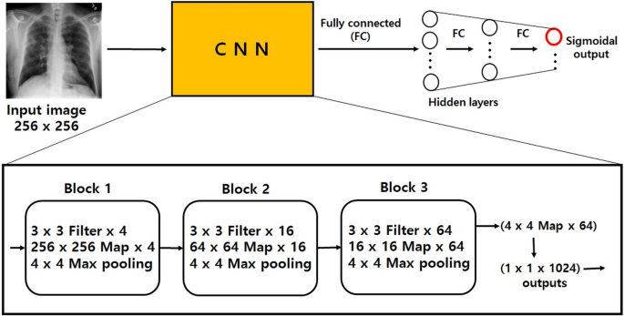](https://www.nature.com/articles/s41598-021-92523-2/figures/2)

**Fig 4.2 The Architecture of Convulutional Neural Network**

**MaxPooling2D layer**

Downsamples the input along its spatial dimensions (height and width) by taking the maximum value over an input window (of size defined by pool size) for each channel of the input. The window is shifted by strides along each dimension.

The resulting output, when using the "valid" padding option, has a spatial shape (number of rows or columns) of: output_shape = math.floor((input_shape - pool_size) / strides) + 1 (when input_shape >= pool_size)

The resulting output shape when using the "same" padding option is: output_shape = math.floor((input_shape - 1) / strides) + 1

**Input shape**

• If data_format='channels_last': 4D tensor with shape (batch_size, rows, cols, channels).

• If data_format='channels_first': 4D tensor with shape (batch_size, channels, rows, cols).

**Output shape**

• If data_format='channels_last': 4D tensor with shape (batch_size, pooled_rows, pooled_cols, channels).

• If data_format='channels_first': 4D tensor with shape (batch_size, channels, pooled_rows, pooled_cols).

**Flatten layer**

It is used to flatten the dimensions of the image obtained after convolving it. **Dense:** It is used to make this a fully connected model and is the hidden layer. **Dropout:** It is used to avoid over fitting on the dataset and dense is the output layer contains only one neuron which decide to which category image belongs.

Flatten is used to flatten the input. For example, if flatten is applied to layer having input shape as (batch_size, 2,2), then the output shape of the layer will be (batch_size, 4)

Flatten has one argument as follows

keras.layers.Flatten(data_format = None)

data_format is an optional argument and it is used to preserve weight ordering when switching from one data format to another data format. It accepts either channels_last or channels_first as value. channels_last is the default one and it identifies the input shape as (batch_size, ..., channels) whereas channels_first identifies the input shape as (batch_size, channels, ...)

**Dense layer**

Dense implements the operation: output = activation(dot(input, kernel) + bias) where activation is the element-wise activation function passed as the activation argument, kernel is a weights matrix created by the layer, and bias is a bias vector created by the layer (only applicable if use_bias is True). These are all attributes of Dense.

**Note:** If the input to the layer has a rank greater than 2, then Dense computes the dot product between the inputs and the kernel along the last axis of the inputs and axis 0 of the kernel (using tf.tensordot). For example, if input has dimensions (batch_size, d0, d1), then we create a kernel with shape (d1, units), and the kernel operates along axis 2 of the input, on every sub-tensor of shape (1, 1, d1) (there are batch_size * d0 such sub-tensors). The output in this case will have shape (batch_size, d0, units).

Besides, layer attributes cannot be modified after the layer has been called once (except the trainable attribute). When a popular kwarg input_shape is passed, then keras will create an input layer to insert before the current layer. This can be treated equivalent to explicitly defining an InputLayer.

**Input shape**

N-D tensor with shape: (batch_size, ..., input_dim). The most common situation would be a 2D input with shape (batch_size, input_dim).

**Output shape**

N-D tensor with shape: (batch_size, ..., units). For instance, for a 2D input with shape (batch_size, input_dim), the output would have shape (batch_size, units).

**Dropout layer**

The Dropout layer randomly sets input units to 0 with a frequency of rate at each step during training time, which helps prevent overfitting. Inputs not set to 0 are scaled up by 1/(1 - rate) such that the sum over all inputs is unchanged.

Note that the Dropout layer only applies when training is set to True such that no values are dropped during inference. When using model.fit, training will be appropriately set to True automatically, and in other contexts, you can set the kwarg explicitly to True when calling the layer.

(This is in contrast to setting trainable=False for a Dropout layer. trainable does not affect the layer's behavior, as Dropout does not have any variables/weights that can be frozen during training.)

**Arguments**

**rate:** Float between 0 and 1. Fraction of the input units to drop.

**noise_shape:** 1D integer tensor representing the shape of the binary dropout mask that will be multiplied with the input. For instance, if your inputs have shape (batch_size, timesteps, features) and you want the dropout mask to be the same for all timesteps, you can use noise_shape=(batch_size, 1, features).

**seed:** A Python integer to use as random seed.

**Image Data Generator:**

It is that rescales the image, applies shear in some range, zooms the image and does horizontal flipping with the image. This Image Data Generator includes all possible orientation of the image.

**Training Process:**

Train_datagen.flow_from_directory is the function that is used to prepare data from the train_dataset directory Target_size specifies the target size of the image. Test_datagen.flow_from_directory is used to prepare test data for the model and all is similar as above. fit_generator is used to fit the data into the model made above, other factors used are steps_per_epochs tells us about the number of times the model will execute for the training data.

**Epochs:**

It tells us the number of times model will be trained in forward and backward pass.

**Validation process:**

Validation_data is used to feed the validation/test data into the model. Validation_steps denotes the number of validation/test samples.

**4.3 ALEXNET:**

AlexNet is the name of a convolutional neural network which has had a large impact on the field of machine learning, specifically in the application of deep learning to machine vision. AlexNet was the first convolutional network which used GPU to boost performance.

AlexNet architecture consists of 5 convolutional layers, 3 max-pooling layers, 2 normalization layers, 2 fully connected layers, and 1 softmax layer. Each convolutional layer consists of convolutional filters and a nonlinear activation function ReLU. The pooling layers are used to perform max pooling.

**4.3.1 Architecture of AlexNet:**

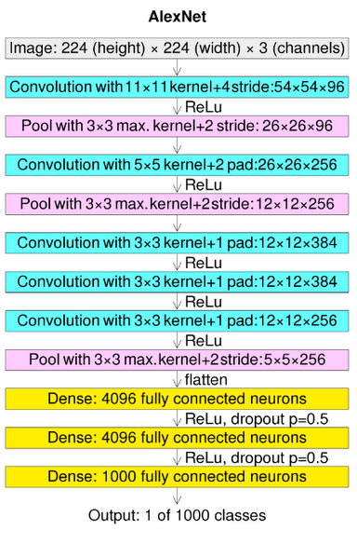

**Fig 4.3**: Architecture of AlexNet

**Pooling layers:**

Pooling layers are similar to convolutional layers, but they perform a specific function such as max pooling, which takes the maximum value in a certain filter region, or average pooling, which takes the average value in a filter region. These are typically used to reduce the dimensionality of the network.

**Dense or Fully connected layers:**

Fully connected layers are placed before the classification output of a CNN and are used to flatten the results before classification. This is similar to the output layer of an MLP.

**4.4 LENET**

LeNet was one among the earliest convolutional neural networks which promoted the event of deep learning. After innumerous years of analysis and plenty of compelling iterations, the end result was named LeNet.

**4.4.1 Architecture of LeNet-5**

LeNet-5 CNN architecture is made up of 7 layers. The layer composition consists of 3 convolutional layers, 2 subsampling layers and 2 fully connected layers

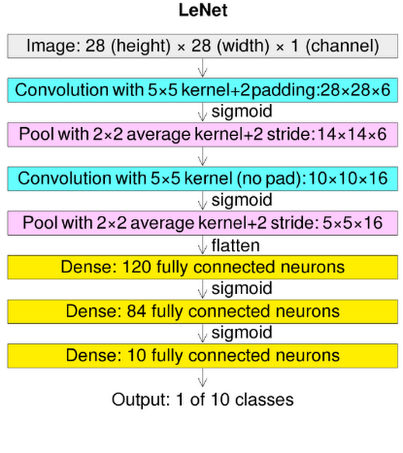

**Fig 4.4:** Architecture of LeNet

**4.5 Preparing The Dataset:**

This dataset contains approximately 992 train and 225 test image records which were then classified into 2 classes:

NORMAL

PNEUMOTHORAX

**4.6 Import The Given Image From Dataset:**

We have to import our data set using keras preprocessing image data generator function also we create size, rescale, range, zoom range, horizontal flip. Then we import our image dataset from folder through the data generator function. Here we set train, test, and validation also we set target size, batch size and class-mode from this function we have to train using our own created network by adding layers of CNN.

**4.7 To Train The Module By Given Image Dataset:**

To train our dataset using classifier and fit generator function also we make training steps per epoch’s then total number of epochs, validation data and validation steps using this data we can train our dataset.

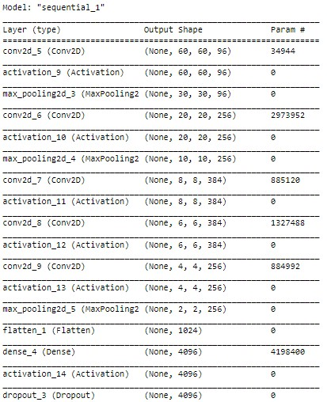

**Fig 4.5:** CNN Model Summary details

**4.8 Working Process Of Layers In Cnn Model:**

A Convolutional Neural Network (ConvNet/CNN) is a Deep Learning algorithm which can take in an input image, assign importance (learnable weights and biases) to various aspects/objects in the image and be able to differentiate one from the other. The pre-processing required in a ConvNet is much lower as compared to other classification algorithms. While in primitive methods filters are hand-engineered, with enough training, ConvNets have the ability to learn these filters/characteristics. The architecture of a ConvNet is analogous to that of the connectivity pattern of Neurons in the Human Brain and was inspired by the organization of the Visual Cortex. Individual neurons respond to stimuli only in a restricted region of the visual field known as the Receptive Field. Their network consists of four layers with 1,024 input units, 256 units in the first hidden layer, eight units in the second hidden layer, and two output units.

Input layer in CNN contain image data. Image data is represented by three dimensional matrixes. It needs to reshape it into a single column. Suppose you have image of dimension 28 x 28 =784, it need to convert it into 784 x 1 before feeding into input.

**Convo Layer:**

Convo layer is sometimes called feature extractor layer because features of the image are get extracted within this layer. First of all, a part of image is connected to Convo layer to perform convolution operation as we saw earlier and calculating the dot product between receptive field (it is a local region of the input image that has the same size as that of filter) and the filter. Result of the operation is single integer of the output volume. Then the filter over the next receptive field of the same input image by a Stride and do the same operation again. It will repeat the same process again and again until it goes through the whole image. The output will be the input for the next layer.

**Pooling Layer:**

Pooling layer is used to reduce the spatial volume of input image after convolution. It is used between two convolution layers. If it applies FC after Convo layer without applying pooling or max pooling, then it will be computationally expensive. So, the max pooling is only way to reduce the spatial volume of input image. It has applied max pooling in single depth slice with Stride of 2. It can observe the 4 x 4 dimension input is reducing to 2 x 2 dimensions.

**Softmax / Logistic Layer:**

Softmax or Logistic layer is the last layer of CNN. It resides at the end of FC layer. Logistic is used for binary classification and softmax is for multi-classification.

**Output Layer:**

Output layer contains the label which is in the form of one-hot encoded. Now you have a good understanding of CNN.

**4.9 Work Flow Diagram:**

Prediction of Pneumothorax disease

CNN algorithm

Testing

Dataset

Training

Dataset

Source images

**Fig:4.6** The Work Flow Diagram

**4.10 Advantages:**

* The large amount of chest x-ray data can be train on artificial neural network.
* It is best model for deep learning technique to easily classifying Pneumothorax.

**CHAPTER 5**

**SOFTWARE IMPLEMENTATION**

**5.1 Working Process:**

1**.Software Requirements:**

Operating System : Windows / Linux

Simulation Tool : Anaconda with Jupyter Notebook

2. **Hardware requirements**:

Processor : Pentium IV/III

Hard disk : minimum 80 GB

RAM : minimum 2 GB

* Download and install anaconda and get the most useful package for machine learning in Python.
* Load a dataset and understand its structure using statistical summaries and data visualization.
* Machine learning models, pick the best and build confidence that the accuracy is reliable.

The default installation of Anaconda2 includes Python 2.7 and Anaconda3 includes Python 3.7. However, you can create new environments that include any version of Python packaged with conda.

Executing a notebook: Download the notebook you want to execute and put it in your notebook folder (or a sub-folder of it).

* Launch the jupyter notebook app
* In the [Notebook Dashboard](https://jupyter-notebook-beginner-guide.readthedocs.io/en/latest/what_is_jupyter.html#dashboard) navigate to find the notebook: clicking on its name will open it in a new browser tab.
* Click on the menu *Help -> User Interface Tour* for an overview of the [Jupyter Notebook App](https://jupyter-notebook-beginner-guide.readthedocs.io/en/latest/what_is_jupyter.html" \l "notebook-app) user interface.
* You can run the notebook document step-by-step (one cell a time) by pressing *shift + enter*.
* You can run the whole notebook in a single step by clicking on the menu *Cell -> Run All*.
* To restart the [kernel](https://jupyter-notebook-beginner-guide.readthedocs.io/en/latest/what_is_jupyter.html#kernel) (i.e. the computational engine), click on the menu *Kernel -> Restart*. This can be useful to start over a computation from scratch (e.g. variables are deleted, open files are closed, etc…).

**5.2 Splitting the dataset:**

The data use is usually split into training data and test data. The training set contains a known output and the model learns on this data in order to be generalized to other data later on. It has the test dataset (or subset) in order to test our models and it will do this using Tensor flow library in Python using the Keras method.

**5.3 Construction of a Detecting Model:**

Deep learning needs data gathering have lot of past image data’s. Training and testing this model working and predicting correctly.

**5.4 PYCHARM:**

In our project we had used PYCHARM (2022.1.1) version for implementing the source code.

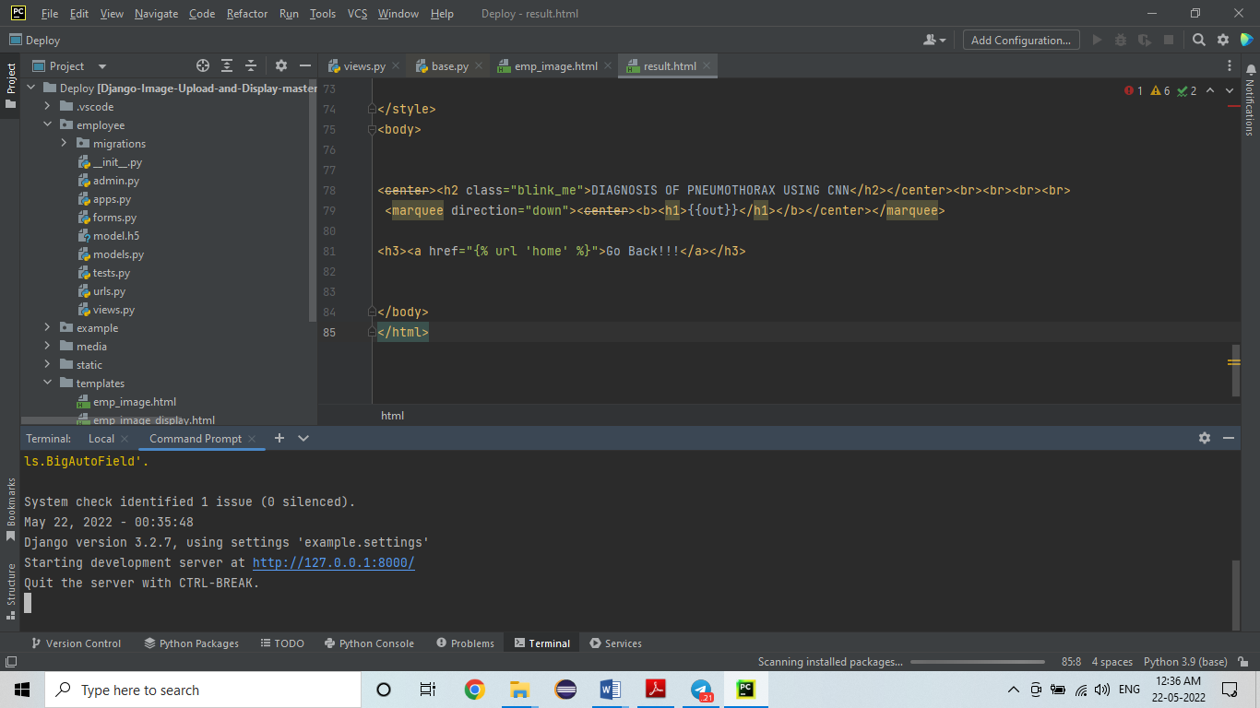**Fig: 5.1** Source code Implementation in Pycharm

**5.5 LIST OF MODULES:**

1. Modified Architecture

2. AlexNet

3. LeNet

4. Deploy

**Libraries Required:**

**tensorflow:** Just to use the tensor board to compare the loss and adam curve our result data or obtained log.

**keras:** To pre-process the image dataset.

matplotlib: To display the result of our predictive outcome.

**os**: To access the file system to read the image from the train and test directory from our machines.

Deploying the model in Django Framework and predicting output

In this module the trained deep learning model is converted into hierarchical data format file (.h5 file) which is then deployed in our django framework for providing better user interface and predicting the output whether the given image is PNEUMOTHORAX and NORMAL.

**CHAPTER 6**

**RESULTS AND DISCUSSION**

Python has emerged as one of the most simple and efficient languages for implementing deep learning algorithms. It is used in various image classification and segmentation tasks.The code for the present work was written in Python. The following important libraries of Python were utilized for developing the proposed model: Keras, Tensorflow,and h5py.

**6.1 Results for Pneumothorax**

The proposed LENET model identify the images with more accuracy rate for identification of Pneumothorax disease. Further, it assigns class labels for each detected region with a prediction confidence score. The proposed model predicted the confidence score for each image efficiently.

**6.2 Analysis Based on Loss Scores**

The loss score of a neural network represents the prediction error of the model. A curve can be plotted to represent the loss generated by the predictions of a model. The model is designed to minimize the loss function.

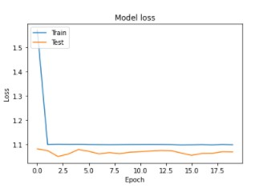

**Fig: 6.1** CNN model trained dataset loss values

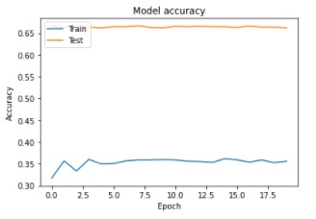

**Fig: 6.2** CNN model trained dataset accuracy

**6.3 Evaluation metrics**

The evaluation of the classification considered four metrics: Specificity (Sp), Sensitivity (Se), Accuracy (Acc), and AUC. The AUC is an area under the Receiver Operating Characteristics (ROC) curve. The AUC is calculated by Riemann sum with a set of thresholds to compute pairs of True Positive Rate (TPR) and False Positive Rate (FPR). Hosmer and Lemeshow provided the guidelines for rating the AUC values (Hosmer, Lemeshow, and Sturdivant 2013). **Table IV** describes the brief guideline rules of the AUC interpretation. Specificity is the fraction of negative test results that are correctly identified as normal. Sensitivity is the probability of positive test results that are correctly identified as pneumothorax. Accuracy is the average of specificity and sensitivity. Specificity and sensitivity are defined with four measurements in following:

• True Positive (TP): Correctly detected as pneumothorax

• True Negative (TN): Correctly detected as normal

• False Positive (FP): Incorrectly detected as pneumothorax

• False Negative (FN): Incorrectly detected as normal

Using the above measurement, specificity (Sp) and sensitivity (Se) are defined in following:

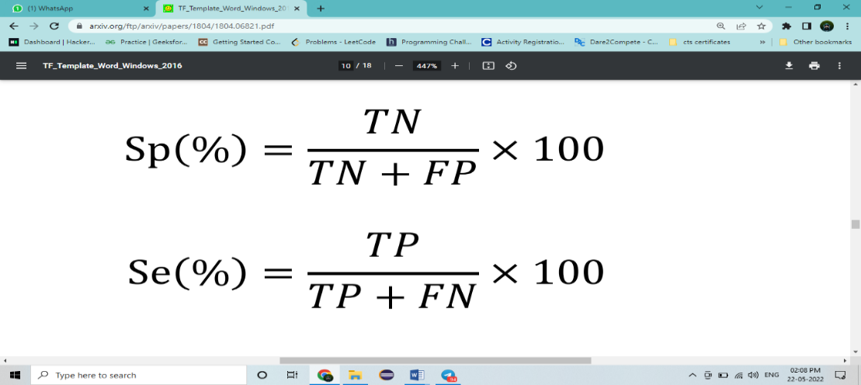

There is a trade-off between specificity and sensitivity. When the softmax layer is used as the final prediction layer, it classifies the input as the class with the highest probability. The problem is that medical data generally consists of multiple normal and few abnormal (disease) data. In this case, training is processed in the direction of reducing the loss of normal which occupies the majority in the mini-batch. Therefore, when the probability of softmax is directly used for class determination, extremely high specificity and low sensitivity are obtained. To avoid this problem, we chose the cut-off value as the point where the sum of specificity and sensitivity in the ROC curve is the maximum.

**TABLE IV**

**AUC interpretation & guidelines**

|  |  |
| --- | --- |
| AUC interpretation guidelines | AUC Guidelines |
| 0.5 – 0.6 | No discrimination |
| 0.6 – 0.7 | Poor discrimination |
| 0.7 – 0.8 | Acceptable discrimination |
| 0.8 – 0.9 | Good discrimination |
| 0.9 – 1.0 | Excellent discrimination |

|  |  |  |  |
| --- | --- | --- | --- |
| **ARCHITECTURE** | **AUC** | **Sp(%)** | **Acc(%)** |
| ALEX NET | 58 | 60.01 | 61.08 |
| LENET | 90 | |89.03 | 88.02 |

**Fig: Working Process of ALEXNET**

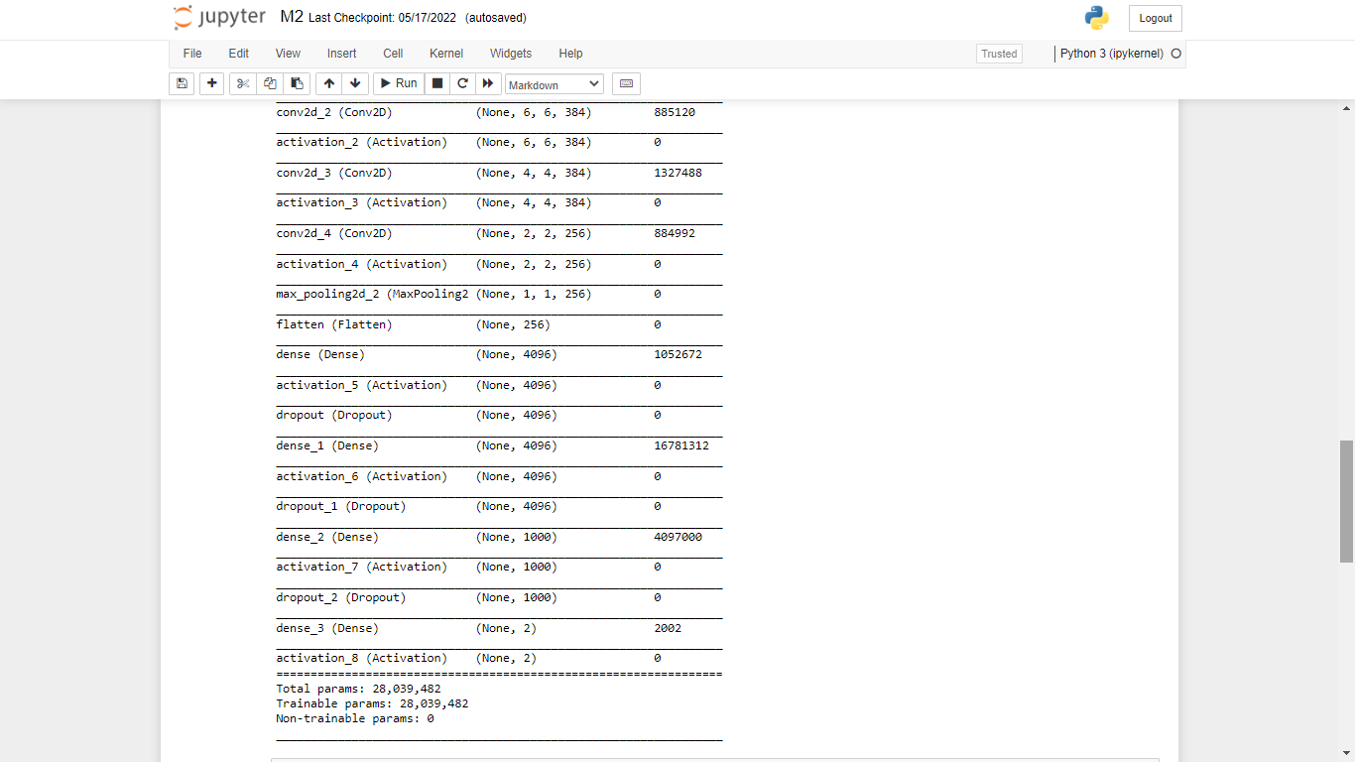

**Fig: Filters Used in Alexnet Architecture**

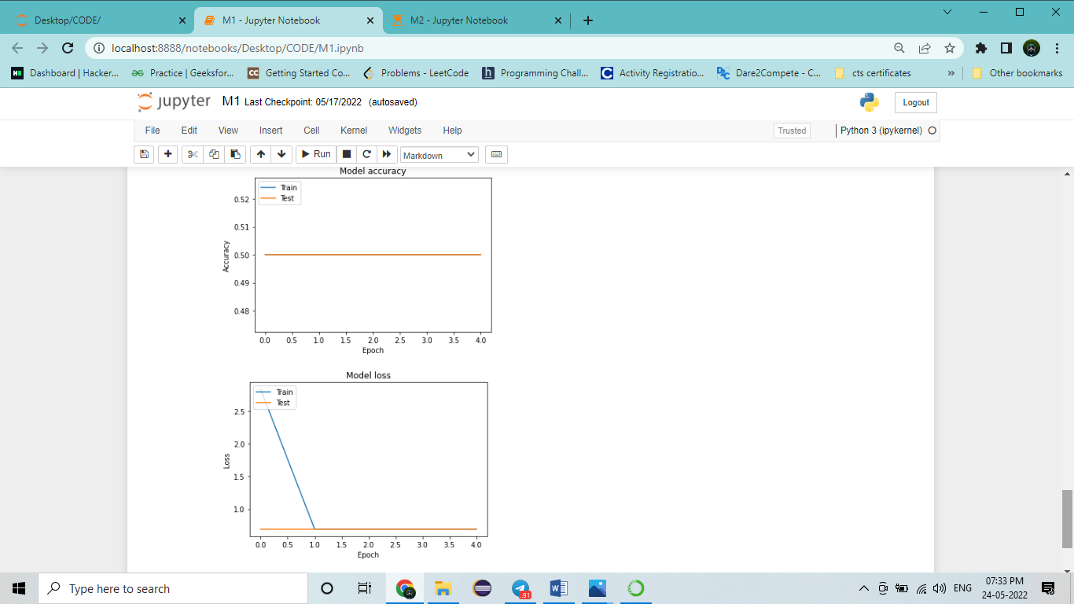

**Fig: Graph for AlexNet Architecture**

**Fig:Working Process of LENET** 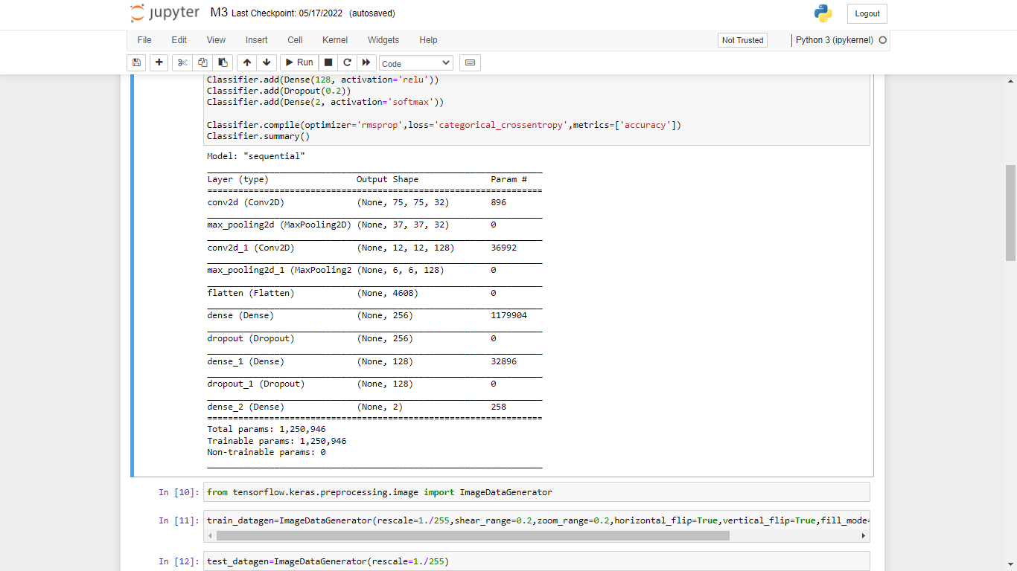

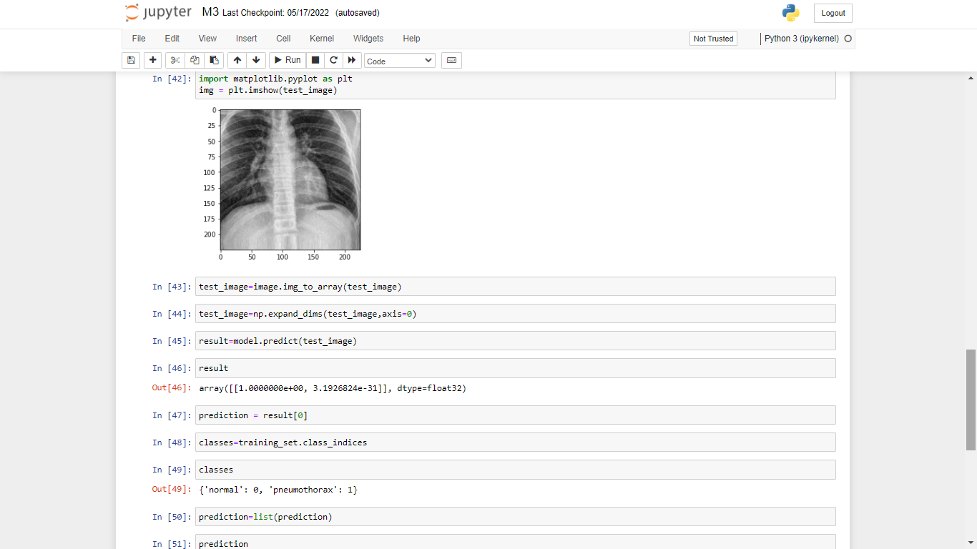

**Fig:Import the data in LENET**

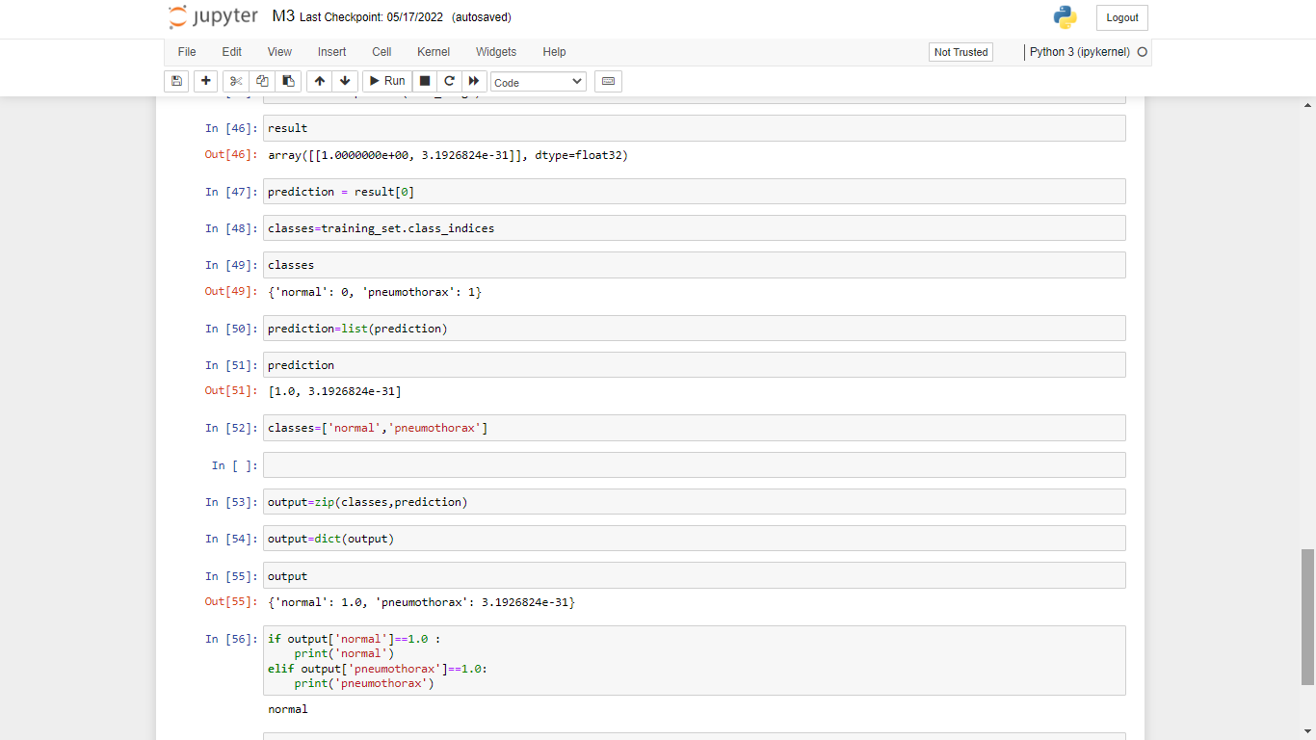

**C)**

**6.4 Output Screenshot Of Proposed System:**

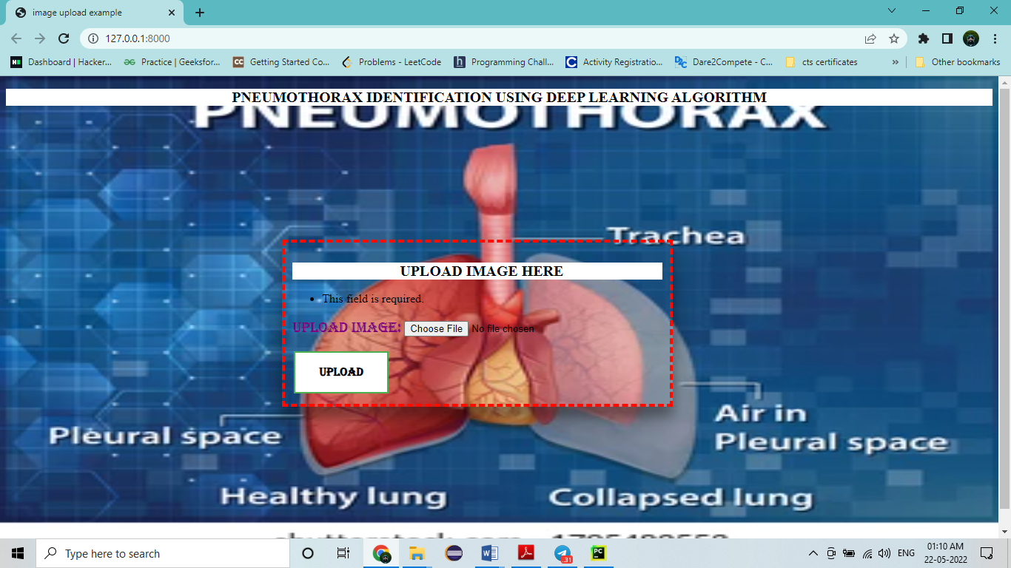

**Fig:6.3** Pneumothorax Identified Using CNN

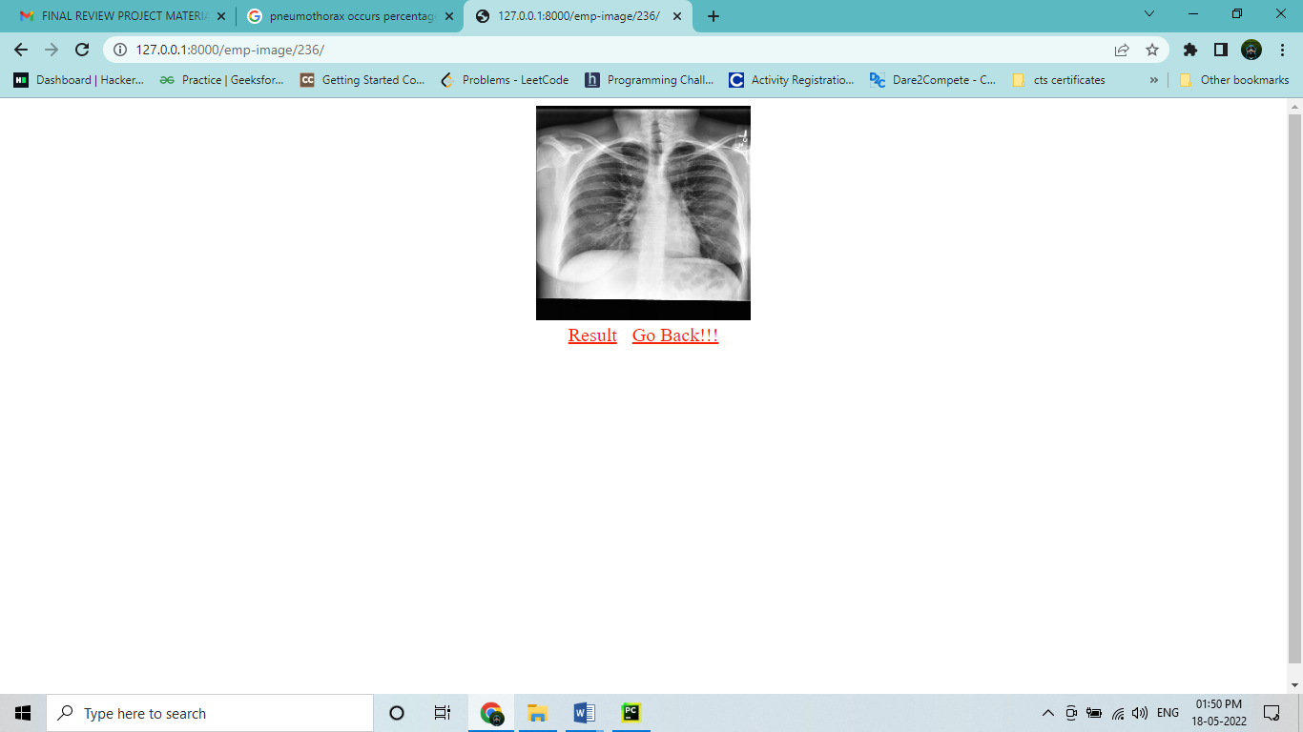

**Fig: 6.4** Input Image data sample

**Fig:6.5** Final Output of Proposed System

**CHAPTER 7**

**CONCLUSION AND FUTURE WORK**

**7.1 Conclusion:**

It focused how image from given dataset (trained dataset) and past data set used to predict the pattern of pneumothorax disease using CNN model. This brings some of the following insights about pneumothorax disease prediction. The major benefit of the CNN classification framework is the ability to classify images automatically. The pneumothorax diseases mainly contribute to misshape and often can’t be remedied because the patients are diagnosed too late with the diseases. We observed that deep learning is capable of achieving a relatively high diagnosis accuracy, is very much in agreement with human diagnostic performance, but still inferior to experienced radiologists in difficult-to-analyze cases.

In this study, we have discussed the overview of methodologies for detecting the abnormalities in pneumothorax images which includes collection of pneumothorax image data set, preprocessing techniques, feature extraction techniques.

**7.2 Future Work:**

Medical department wants to automate the detecting of pneumothorax disease from eligibility process (real time).

To optimize the work to implement in Artificial Intelligence environment.

**APPENDICES:**

**Modified Architechture of CNN**

**To build a model for training and testing:**

import os

import numpy as np # linear algebra

import matplotlib.pyplot as plt

# Dl framwork - tensorflow, keras a backend

import tensorflow as tf

import tensorflow.keras.backend as K

from tensorflow.keras.models

import Model, Sequential

from tensorflow.keras.layers

import Input, Dense, Flatten, Dropout, BatchNormalization

from tensorflow.keras.layers import Conv2D, SeparableConv2D, MaxPool2D, LeakyReLU, Activation

from tensorflow.keras.optimizers

import Adam

from tensorflow.keras.preprocessing.image

import ImageDataGenerator

from tensorflow.keras.callbacks

import ModelCheckpoint,ReduceLROnPlateau, EarlyStopping

from IPython.display

import display

from os import listdir

from os.path import isfile, join

from PIL import Image

import glob

from tensorflow.keras.preprocessing.image

import ImageDataGenerator

from tensorflow.keras.layers

import Convolution2D

from tensorflow.keras.layers

import MaxPooling2D

from tensorflow.keras.layers

import Flatten

from tensorflow.keras.layers

import Dense

import warnings

warnings.filterwarnings('ignore')

dir_name_train_normal = 'data/train/normal'

dir_name_train_pneumothorax = 'data/train/pneumothorax'

def plot_images(item_dir, n=6):

all_item_dir = os.listdir(item_dir)

item_files = [os.path.join(item_dir, file) for file in all_item_dir][:n]

plt.figure(figsize=(80, 40))

for idx, img_path in enumerate(item_files):

plt.subplot(7, n, idx+1)

img = plt.imread(img_path)

plt.imshow(img, cmap='gray')

plt.axis('off')

plt.tight_layout()

def Images_details_Print_data(data, path):

print(" ====== Images in: ", path)

for k, v in data.items():

print("%s:\t%s" % (k, v))

def Images_details(path):

files = [f for f in glob.glob(path + "**/*.*", recursive=True)]

data = {}

data['images_count'] = len(files)

data['min_width'] = 10**100 # No image will be bigger than that

data['max_width'] = 0

data['min_height'] = 10**100 # No image will be bigger than that

data['max_height'] = 0

for f in files:

im = Image.open(f)

width, height = im.size

data['min_width'] = min(width, data['min_width'])

data['max_width'] = max(width, data['max_width'])

data['min_height'] = min(height, data['min_height'])

data['max_height'] = max(height, data['max_height'])

Images_details_Print_data(data, path)

print("")

print("Trainned data for normal Disease :")

print("")

Images_details(dir_name_train_normal)

print("")

plot_images(dir_name_train_normal, 10)

Trainned data for normal Disease :

====== Images in: data/train/normal

images_count: 416

min_width: 400

max_width: 2916

min_height: 300

max_height: 2713

print("")

print("Trainned data for pneumothorax:")

print("")

Images_details(dir_name_train_pneumothorax)

print("")

plot_images(dir_name_train_pneumothorax, 10)

Classifier=Sequential()

Classifier.add(Convolution2D(32,(3,3),input_shape=(128,128,3),activation='relu'))

Classifier.add(MaxPooling2D(pool_size=(2,2)))

Classifier.add(Flatten())

Classifier.add(Dense(38, activation='relu'))

Classifier.add(Dense(1, activation='sigmoid'))

Classifier.compile(optimizer='rmsprop',loss='binary_crossentropy',metrics=['accuracy'])

train_datagen=ImageDataGenerator(rescale=1./255,shear_range=0.2,zoom_range=0.2,horizontal_flip=True)

test_datagen=ImageDataGenerator(rescale=1./255)

training_set=train_datagen.flow_from_directory('data/train',target_size=(128,128),batch_size=32,class_mode='categorical')

test_set=test_datagen.flow_from_directory('data/test',target_size=(128,128),batch_size=32,class_mode='categorical')

epochs = 5

batch_size = 32

#### Fitting the model

history=Classifier.fit_generator(training_set, steps_per_epoch=training_set.samples // batch_size,

epochs=epochs,

validation_data=test_set,validation_steps=test_set.samples // batch_size)

def graph():

#Plot training & validation accuracy values

plt.plot(history.history['accuracy'])

plt.plot(history.history['val_accuracy'])

plt.title('Model accuracy')

plt.ylabel('Accuracy')

plt.xlabel('Epoch')

plt.legend(['Train', 'Test'], loc='upper left')

plt.show()

# Plot training & validation loss values

plt.plot(history.history['loss'])

plt.plot(history.history['val_loss'])

plt.title('Model loss')

plt.ylabel('Loss')

plt.xlabel('Epoch')

plt.legend(['Train', 'Test'], loc='upper left')

plt.show()

graph()

**ALEXNET**

# Dl framwork - tensorflow, keras a backend

import tensorflow as tf

import tensorflow.keras.backend as K

from tensorflow.keras.models import Model

from tensorflow.keras.models import Sequential

from tensorflow.keras.layers import Input

from tensorflow.keras.layers import Dense

from tensorflow.keras.layers import Flatten

from tensorflow.keras.layers import Conv2D

from tensorflow.keras.layers import MaxPooling2D

from tensorflow.keras.layers import Dropout

from tensorflow.keras.layers import LeakyReLU

from tensorflow.keras.layers import Activation

from tensorflow.keras.optimizers import Adam

from tensorflow.keras.preprocessing.image import ImageDataGenerator

from tensorflow.keras.callbacks import ModelCheckpoint

from tensorflow.keras.callbacks import ReduceLROnPlateau

from tensorflow.keras.callbacks import EarlyStopping

import warnings

warnings.filterwarnings('ignore')

model = Sequential()

# 1st Convolutional Layer

model.add(Conv2D(filters=96,input_shape=(224,224,3), kernel_size=(11,11), strides=(4,4), padding='valid'))

model.add(Activation('relu'))

# Max Pooling

model.add(MaxPooling2D(pool_size=(2,2), strides=(2,2), padding='valid'))

# 2nd Convolutional Layer

model.add(Conv2D(filters=256, kernel_size=(11,11), strides=(1,1), padding='valid'))

model.add(Activation('relu'))

# Max Pooling

model.add(MaxPooling2D(pool_size=(2,2), strides=(2,2), padding='valid'))

# 3rd Convolutional Layer

model.add(Conv2D(filters=384, kernel_size=(3,3), strides=(1,1), padding='valid'))

model.add(Activation('relu'))

# 4th Convolutional Layer

model.add(Conv2D(filters=384,kernel_size=(3,3),strides=(1,1), padding='valid'))

model.add(Activation('relu'))

# 5th Convolutional Layer

model.add(Conv2D(filters=256,kernel_size=(3,3),strides=(1,1), padding='valid'))

model.add(Activation('relu'))

# Max Pooling

model.add(MaxPooling2D(pool_size=(2,2), strides=(2,2), padding='valid'))

# Passing it to a Fully Connected layer

model.add(Flatten())

# 1st Fully Connected Layer

model.add(Dense(4096, input_shape=(224*224*3,)))

model.add(Activation('relu'))

# Add Dropout to prevent overfitting

model.add(Dropout(0.4))

# 2nd Fully Connected Layer

model.add(Dense(4096))

model.add(Activation('relu'))

# Add Dropout

model.add(Dropout(0.4))

# 3rd Fully Connected Layer

model.add(Dense(1000))

model.add(Activation('relu'))

# Add Dropout

model.add(Dropout(0.4))

# Output Layer

model.add(Dense(2))

model.add(Activation('softmax'))

model.summary()

# Compile the model

model.compile(loss='categorical_crossentropy',optimizer='adam', metrics=['accuracy'])

train_datagen=ImageDataGenerator(rescale=1./255,shear_range=0.2,zoom_range=0.2,horizontal_flip=True)

test_datagen=ImageDataGenerator(rescale=1./255)

training_set=train_datagen.flow_from_directory('data/train',target_size=(224,224),batch_size=32,class_mode='categorical')

test_set=test_datagen.flow_from_directory('data/test',target_size=(224,224),batch_size=32,class_mode='categorical')

epochs = 20

batch_size = 32

#### Fitting the model

history = model.fit(training_set, steps_per_epoch=training_set.samples // batch_size,

epochs=epochs,

validation_data=test_set,validation_steps=test_set.samples // batch_size)

import matplotlib.pyplot as plt

def graph():

#Plot training & validation accuracy values

plt.plot(history.history['accuracy'])

plt.plot(history.history['val_accuracy'])

plt.title('Model accuracy')

plt.ylabel('Accuracy')

plt.xlabel('Epoch')

plt.legend(['Train', 'Test'], loc='upper left')

plt.show()

# Plot training & validation loss values

plt.plot(history.history['loss'])

plt.plot(history.history['val_loss'])

plt.title('Model loss')

plt.ylabel('Loss')

plt.xlabel('Epoch')

plt.legend(['Train', 'Test'], loc='upper left')

plt.show()

graph()

print("[INFO] Calculating model accuracy")

scores = model.evaluate(test_set)

print(f"Test Accuracy: {scores[1]*100}")

**LENET**

from tensorflow.keras.callbacks import ModelCheckpoint, ReduceLROnPlateau, EarlyStopping

from tensorflow.keras.models import Sequential

from tensorflow.keras.layers import Convolution2D

from tensorflow.keras.layers import MaxPooling2D

from tensorflow.keras.layers import Flatten

from tensorflow.keras.layers import Dense, Dropout

import warnings

warnings.filterwarnings('ignore')

Classifier=Sequential()

Classifier.add(Convolution2D(32,3,3,input_shape=(225,225,3),activation='relu')

Classifier.add(MaxPooling2D(pool_size=(2,2)))

Classifier.add(Convolution2D(128,3,3,activation='relu'))

Classifier.add(MaxPooling2D(pool_size=(2,2)))

Classifier.add(Flatten())

Classifier.add(Dense(256, activation='relu'))

Classifier.add(Dropout(0.2))

Classifier.add(Dense(128, activation='relu'))

Classifier.add(Dropout(0.2))

Classifier.add(Dense(2, activation='softmax'))

Classifier.compile(optimizer='rmsprop',loss='categorical_crossentropy',metrics=['accuracy'])

Classifier.summary()

from tensorflow.keras.preprocessing.image import ImageDataGenerator

train_datagen=ImageDataGenerator(rescale=1./255,shear_range=0.2,zoom_range=0.2,horizontal_flip=True,vertical_flip=True,fill_mode='reflect',validation_split=0.2)

test_datagen=ImageDataGenerator(rescale=1./255)

training_set=train_datagen.flow_from_directory('data/train',target_size=(225,225),batch_size=32,class_mode='categorical')

test_set=test_datagen.flow_from_directory('data/test',target_size=(225,225),

batch_size=32,class_mode='categorical')

from IPython.display import display

epochs = 20

batch_size =32

Classifier.fit_generator(training_set, steps_per_epoch=training_set.samples // batch_size,

epochs=epochs,

validation_data=test_set,validation_steps=test_set.samples // batch_size)

import h5py

Classifier.save('model.h5')

from keras.models import load_model

model=load_model('model.h5')

import numpy as np

from tensorflow.keras.preprocessing import image

test_image=image.load_img('n.jpeg',target_size=(225,225))

import matplotlib.pyplot as plt

img = plt.imshow(test_image)

test_image=image.img_to_array(test_image)

test_image=np.expand_dims(test_image,axis=0)

result=model.predict(test_image)

result

prediction = result[0]

classes=training_set.class_indices

classes

prediction=list(prediction)

prediction

classes=['normal','pneumothorax']

output=zip(classes,prediction)

output=dict(output)

output

if output['normal']==1.0 :

print('normal')

elif output['pneumothorax']==1.0:

print('pneumothorax')

**REFERENCES**

[1]L. Thomsen, O. Natho, U. Feigen, U. Schulz, and D. Kivelitz, “Value of Digital Radiography in Expiration in Detection of Pneumothorax,” RöFo - Fortschritte Auf Dem Geb. Röntgenstrahlen Bildgeb. Verfahr., vol. 186, no. 03, pp. 267–273, Mar. 2014, doi: 10.1055/s-0033-1350566.

[2] S. Sanada, K. Doi, and H. MacMahon, “Image feature analysis and computer-aided diagnosis in digital radiography: automated detection of pneumothorax in chest images,” Med. Phys., vol. 19, no. 5, pp. 1153–1160, Oct. 1992, doi: 10.1118/1.596790.

[3] O. Geva, G. Zimmerman-Moreno, S. Lieberman, E. Konen, and H. Greenspan, “Pneumothorax detection in chest radiographs using local and global texture signatures,” in Medical Imaging 2015: Computer-Aided Diagnosis, Mar. 2015, vol. 9414, p. 94141P, doi: 10.1117/12.2083128.

[4] Y.-H. Chan, Y.-Z. Zeng, H.-C. Wu, M.-C. Wu, and H.-M. Sun, “Effective Pneumothorax Detection for Chest X-Ray Images Using Local Binary Pattern and Support Vector Machine,” J. Healthc. Eng., vol. 2018, p. 2908517, 2018, doi: 10.1155/2018/2908517.

[5] A. Gooßen et al., “Deep Learning for Pneumothorax Detection and Localization in Chest Radiographs,” ArXiv, 2019.

[6] G. Kitamura and C. Deible, “Retraining an open-source pneumothorax detecting machine learning algorithm for improved performance to medical images,” Clin. Imaging, vol. 61, pp. 15–19, May 2020, doi: 10.1016/j.clinimag.2020.01.008.

[7] R. W. Filice et al., “Crowdsourcing pneumothorax annotations using machine learning annotations on the NIH chest X-ray dataset,” J. Digit. Imaging, Nov. 2019, doi: 10.1007/s10278-019-00299-9.

[8] M. Annarumma, S. J. Withey, R. J. Bakewell, E. Pesce, V. Goh, and G. Montana, “Automated Triaging of Adult Chest Radiographs with Deep Artificial Neural Networks,” Radiology, vol. 291, no. 1, pp. 196–202, Jan. 2019, doi: 10.1148/radiol.2018180921

[9]A. G. Taylor, C. Mielke, and J. Mongan, “Automated detection of moderate and large pneumothorax on frontal chest X-rays using deep convolutional neural networks: A retrospective study,” *PLOS Med.*, vol. 15, no. 11, p. e1002697, Nov. 2018, doi: 10.1371/journal.pmed.1002697.

[10] M. Cicero *et al.*, “Training and Validating a Deep Convolutional Neural Network for Computer-Aided Detection and Classification of Abnormalities on Frontal Chest Radiographs,” *Invest. Radiol.*, vol. 52, no. 5, pp. 281–287, 2017, doi: 10.1097/RLI.0000000000000341.

[11] P. Rajpurkar *et al.*, “Deep learning for chest radiograph diagnosis: A retrospective comparison of the CheXNeXt algorithm to practicing radiologists,” *PLoS Med.*, vol. 15, no. 11, p. e1002686, 2018, doi: 10.1371/journal.pmed.1002686.

[12] X. Ouyang *et al.*, “Weakly Supervised Segmentation Framework with Uncertainty: A Study on Pneumothorax Segmentation in Chest X-ray,” in *Medical Image Computing and Computer Assisted Intervention – MICCAI 2019*, Cham, 2019, pp. 613–621, doi: 10.1007/978-3-030-32226-7_68.

[13] “SIIM-ACR Pneumothorax Segmentation.” https://kaggle.com/c/siim-acr-pneumothorax-segmentation (accessed Mar. 18, 2020).

[14]B. Aramini, C. Ruggiero, A. Stefani, and U. Morandi, “Giant bulla or pneumothorax: How to distinguish,” *Int. J. Surg. Case Rep.*, vol. 62, pp. 21–23, Aug. 2019, doi: 10.1016/j.ijscr.2019.08.003